Inception Report

Support to the Voluntary National Review of the Sustainable Development Goals in Somalia through a Somali Goal Tracker

31st of March 2022

Alexandra Silfverstolpe
Project Title: Support to the Voluntary National Review of the Sustainable Development Goals in Somalia through a Somali Goal Tracker

To the Somali National Bureau of Statistics (SNBS) and the
United Nations Development Programme (UNDP)

Inception Report

This document describes the services to be conducted by the Individual Contractor Alexandra Silfverstolpe in response to the Contract and Terms of Reference for Support to the Voluntary National Review of the Sustainable Development Goals in Somalia through a Somali Goal Tracker at the request of SNBS.

Background

The 2030 Agenda for Sustainable Development and its 17 Sustainable Development Goals (SDGs), adopted by all Member States of the United Nations in September 2015, provide a visionary roadmap for all countries and stakeholders to strive for a world of sustainable prosperity, social inclusion and equality while at the same time preserving our planet and leaving no one behind. For a systematic review of progress in the implementation of the 2030 Agenda, the UN General Assembly and the countries have adopted a monitoring framework through the Voluntary National Review (VNR). This robust, voluntary, participatory, transparent and integrated monitoring and review framework should make a key contribution to implementation and will help countries make maximum progress and monitor progress in implementing the 2030 Agenda to ensure that no one is left behind.

The VNRs are intended to track progress in implementing the 2030 Agenda, including the SDGs and targets, in a manner that respects their universal and integrated nature and all dimensions of sustainable development. The principles guiding follow-up and review at all levels, contained in paragraph 74, provide, among other things, that reviews will be substantive, and knowledge based, as well as open, inclusive, participatory and transparent for all people, with a particular focus on the poorest, most vulnerable and those furthest behind.

After six years of implementation of the 2030 Agenda and Agenda 2063, Somalia is one of the 7 African countries (out of 22 in the world) that will present their first VNR during the High Level Political Forum on Sustainable Development to be held at the High Level Political Forum in July 2022. During August - December 2021 SNBS has through support from the UNDP conducted an analysis of what nationally and internationally produced data and statistics is currently available to track achievement of the SDGs in Somalia (including disaggregation levels). All data was collected in a template that can provide a useful tool for the upcoming VNR.

Objectives
The overall objective of this project is to enable Somalia to track progress against the Sustainable Development Goals (SDGs), by creating an online, user-friendly, open-access portal, based on the Goal Tracker platform. The Somalia Goal Tracker will offer a common platform to identify gaps and opportunities in the implementation of the SDGs, and could thereby increase the impact of all actors’ actions to meet the goals and targets. Besides contributing to the process of compiling the VNR, the Goal Tracker will also increase transparency and accountability for all actors engaged in the 2030 Agenda in Somalia, and thereby add value and greater ownership to the overall operationalisation of the agenda.

The Goal Tracker Platform

Goal Tracker is built on a foundation of core features and data visualization tools that will be adapted to Somalia and SNBS needs. The platform can consume both data and content (such as images, policies and reports). The content is uploaded by the country team through a content management system (CMS), supported by the consultancy team.

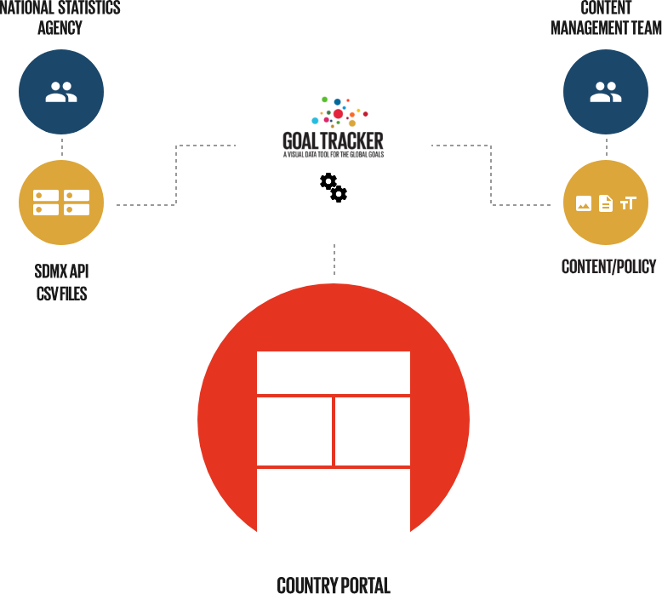

Expected Results
This consultancy focuses on the period March – June 2022. The result will be a Somali Goal Tracker portal with pages and interactive applications for tracking the implementation of the SDGs, linkages with the NDP-9 and AU’s Agenda 2063, based on the data in the template that has already been developed by SNBS. The exact features will, to a large degree, depend on the quality of data and content supplied by the SNBS, but potentially the Somali Goal Tracker portal could include a combination of the following features:
A landing page about the Agenda 2030 in Somalia:
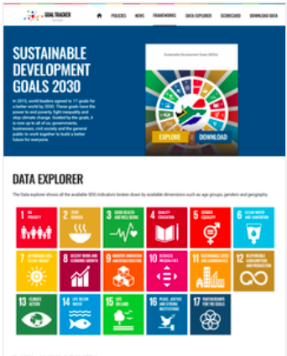 | An interactive landing page that provides easy access to the other content on the website. Entry points to:  Goal pages  Data Explorer  Data Gaps  About pages

Goal pages including highlights and key data
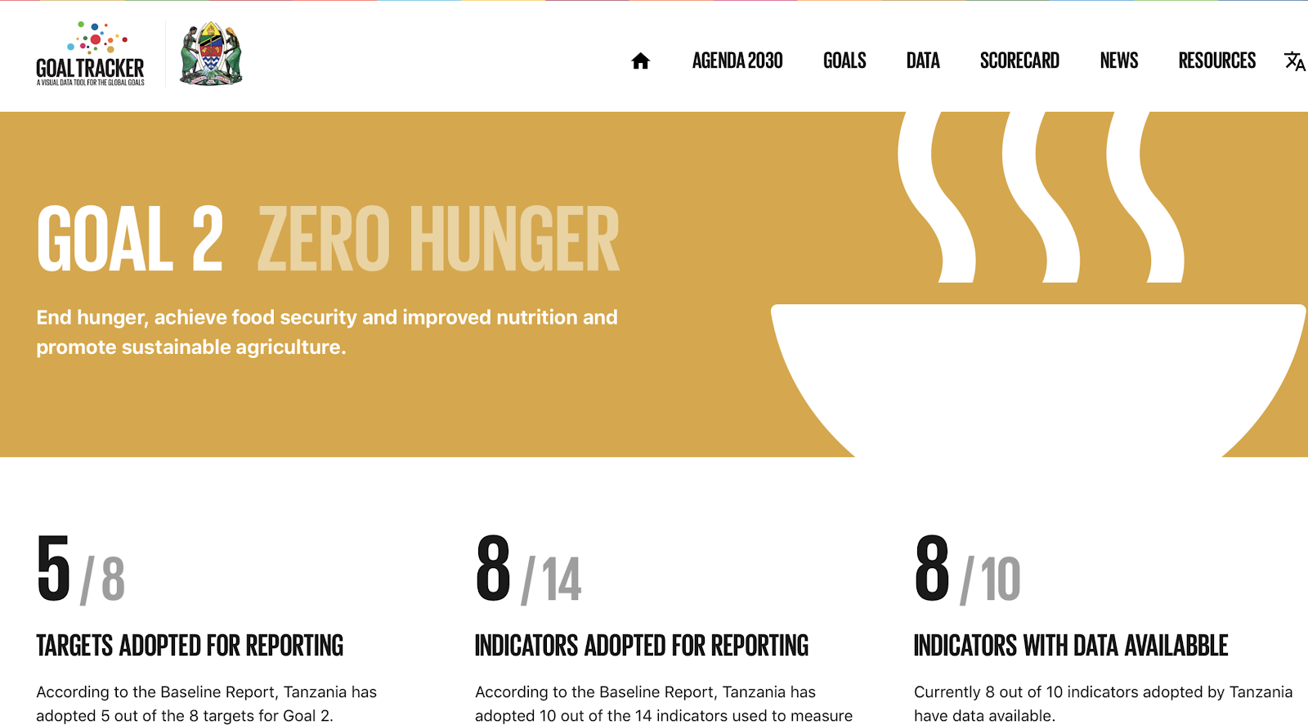 | A Goal page that helps you:  Get an overview of the data availability per goal and target. It could include Somalia policies if a mapping of existing policies to the SDGs has already taken place.The goal page takes you to charts, where available data can be explored in detail.

Data explorer
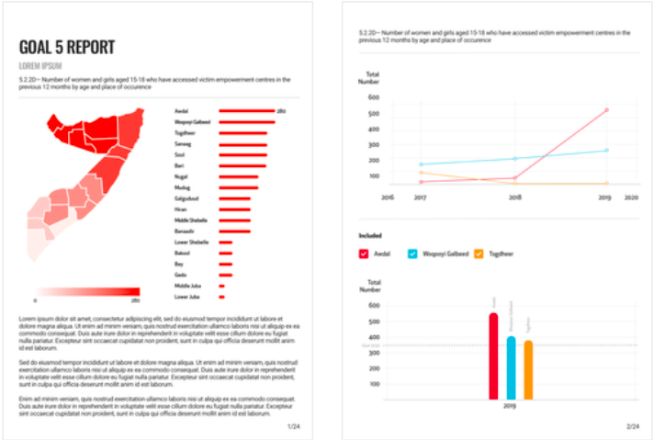 | A tool that helps you:  Track performance at national or subnational level, broken down by for example gender and age (based on data provided)  Learn whether Somalia and the regions are meeting their targets for 2030 and who is left behind.  Get insights into the data via maps, bar charts and line graphs.

Inclusion of other digital tools (Data gaps, Data Ecosystem and linkages NDP/SDG/A2063
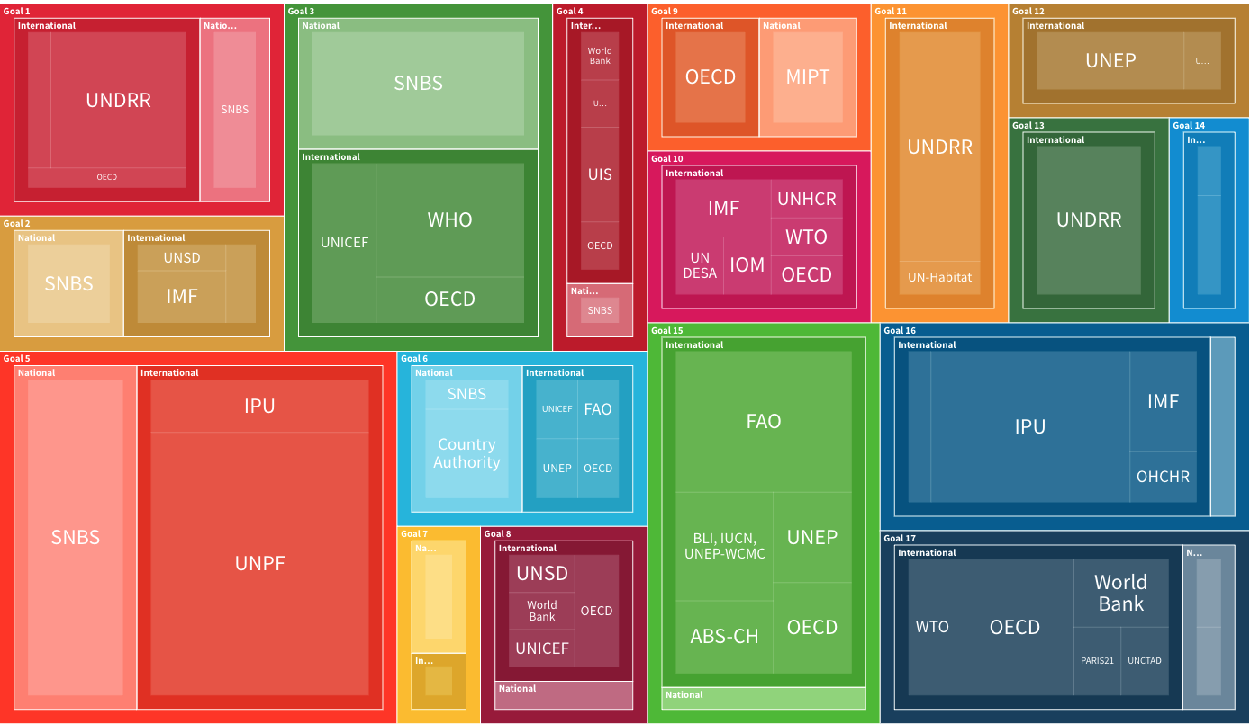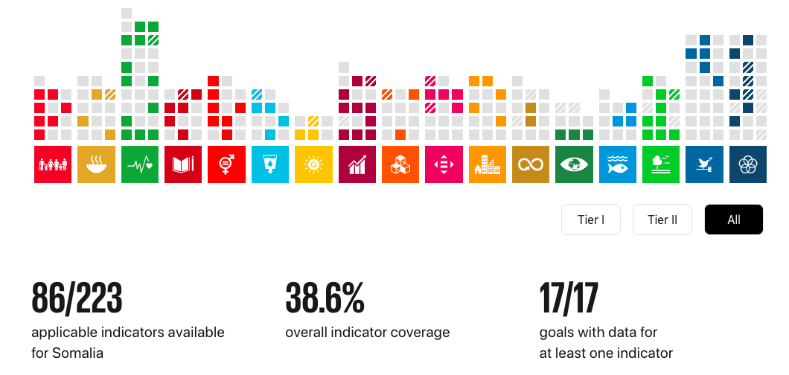

Data Download
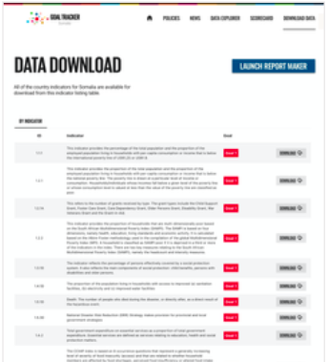 | A tool that helps you share all data and metadata to broad user groups sorted by goal.

Automated Report Maker
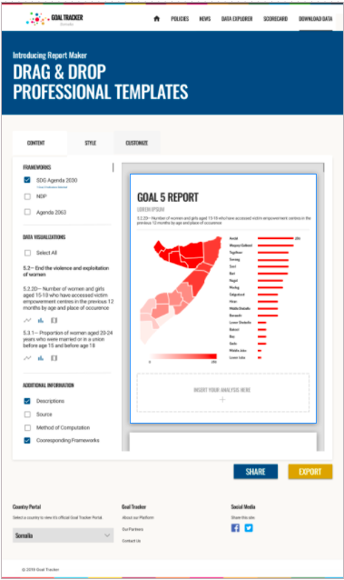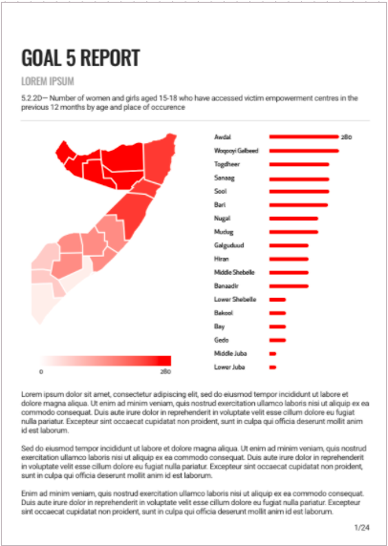 | This involves building an internal editing view on the platform (an addition to the admin capabilities) that can automatically generate a report for a particular goal for example with a number of suggested headings and visualizations.

Activities and Timeline
Kick-off (March 2022)

The project will start with a kick-off revisiting the scope and timeline of the project as well as roles and responsibilities of each team member. A brief introduction will be given on how the Goal Tracker platform works. Tools for collaboration and communication will be set up.

Tools for collaboration and communication:
- The Consultant creates calendar invitations for meetings to keep track of the project
- The Consultant provides an overview of the Goal Tracker Platform and services
- Both teams exchange communication channels between the teams

Key roles & responsibilities
- SNBS designates team members to fulfill the required roles for the project. SNBS is expected to take an active role in the project and provide continuous feedback and input to the process (on a weekly basis during the project period)
- SNBS communicates about team availability

Research: Content and concept inventory (by 8 April)

Based on an online form developed by the Consultant, SNBS will submit answers on available content related to the SDG, NDP and Agenda 2063 (policies, reports, images, texts, news) which may be included in Somali Goal Tracker through the CMS.

During this period SNBS will also review the data that is already in the Somalia data template, and also fill in metadata if that is lacking (definitions, methods of computation and data sources).

Based on the input from SNBS a set of customized concepts and priorities for the Somalia Goal Tracker will be shared with the SNBS.

Develop a Beta Version of Somali Goal Tracker (by 30 April)

In parallel with the scoping phase, the Somali Goal Tracker platform will be created and configured. A developmental version of the Somali portal will be made available.

The pages in Goal Tracker that show content such as policies, publications and news items, will be created and integrated into the CMS. Access will be granted to SNBS for managing content and capacitation of the team on how to do so will occur.

Steps for configuration
- Create and deploy Somali Goal Tracker
- Add content in the CMS (available at this point)
- Create and populate a Github repository with Somali data (available at this point)
- Set up of (internal) Beta version of Somali Goal Tracker portal by 30 April

Development of Automated Report Maker (April - May)

This involves building an internal editing view on the platform (an addition to the admin capabilities) that can automatically generate an outline for a report with a number of suggested headings and visualizations. The visualizations would be automatically created from the database and the text can be further edited to create a report in a fraction of the time compared to a standard, non data-driven approach.

Testing of Beta version (May onwards)

By 30 April, SNBS will be given access to its Goal Tracker portal in an internal beta version. During May the portal will be tested and SNBS and the Consultant will continuously refine its data and content. SNBS provides feedback and continues to add and refine content on the platform (via the administrative features).

Preparation for launch (May)

As part of the Somali Goal Tracker functionality, there will be a kit of resources available for marketing (smaller set of banners that can be shared in social media and other channels) and for the launch. The SNBS and the Consultant will jointly decide on the date for the launch (preliminary set for mid- June).

Training of SNBS on data workflows and portal updates (June)

A written user guideline on how to update the Goal Tracker with new data and content will be developed and shared. The training will build capacity on how to:

- Update data and metadata on the platform
- Update key content (policy documents, reports images, text) through the CMS.

Launch of the Somali Goal Tracker and inclusion of the SNBS website (30 June)

